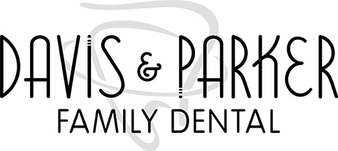

New Patient Appointment Acknowledgment

Welcome to Davis Family Dental! We are so excited to meet you!

Please review the following:
In order to serve our patients best, a new patient appointment consists of a comprehensive exam with the doctor and X-rays (as needed) This initial appointment does NOT include a cleaning or treatment. This enables us to schedule and provide the most appropriate cleaning and treatment per each individual patient.
This office policy is non-negotiable

Print Name: __________________________________________________ Date: ____________

