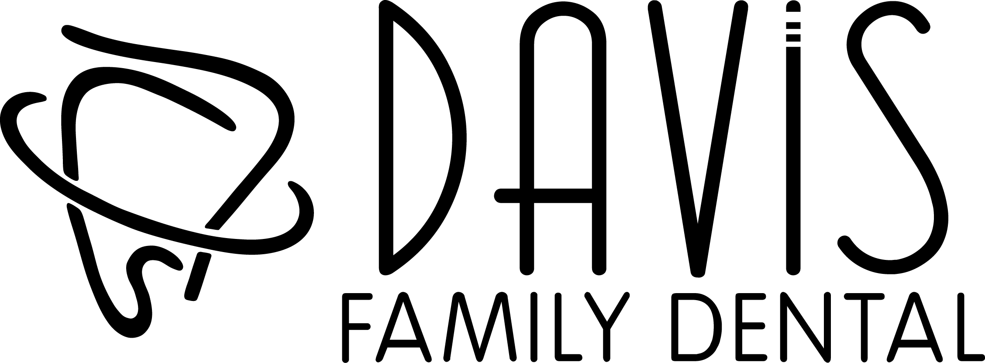

NO-SHOW, LATE-SHOW or LATE CANCELLATIONS
POLICY

No-shows, late-shows or late cancellations unnecessarily delay the delivery of oral health care to our patients, some of whom may have a dental emergency. Your appointment time is reserved for you, so please help us to provide the best possible care to patients in our community by notifying us as soon as possible when you cannot make an appointment!

NO-SHOW or LATE CANCELLATION POLICY

- A no-show or late cancellation is defined as missing a scheduled appointment, without:
At least a 24 hours in advance notice for a scheduled appointment.

- You will be charged a $50.00 no-show fee per missed appointment.
- Families or individuals who have missed appointments on 3 separate days within 12 months may be subject to dismissal from the practice.
- Davis Family Dental will attempt to contact you starting with 2 weeks in advance, 2 days in advance and 1 hour in advance. **Confirmation calls are a courtesy. It is ultimately your responsibility to mark your calendar for your appointment.**
- Additionally, it is your responsibility to provide Davis Family Dental accurate and up-to-date contact information

LATE-SHOW POLICY

- A patient who is more than 10 minutes late to an appointment may be asked to reschedule their appointment or at least not receive all procedures planned for that time.

We are a small practice and hold firm to our schedule and policies. If you have difficulty making appointment, we may suggest you see a larger office with more chairs to accommodate your schedule.

I have read and understand the above policies and agree to the terms outlined above.

___________________________________ _____________________
Signature (Patient or Responsible Party) Date

